# DATAFLOW (PIPE & FILTER) ARCHITECTURAL STYLE

**RATIONALE:**

The use of the Pipe and Filter architectural pattern provides a structure of the data flow within the petrol station. The pipe and filter style shows components that process a stream of data (filters) and connections that transmit data between adjacent components (pipes). This architecture style was chosen as it provides reusability, maintainability, and decoupling of system processes by having distinctive, identifiable and independent tasks that can be rearranged.

The pipe and filter style works to this system, as the order in which filters are processed is determined and sequential in nature. It applies to the problem where it is natural to decompose the computation into a collection of semi-independent tasks such as the task carried out at the pump and through to the POS controller.

**COMPONENT AND CONNECTOR DESCRIPTION:**

1. **Input**
   1. This is the action from the nozzle; actions include picked up, placed back and pulling of the trigger to dispense the additive.
2. **Fuel Type Determiner Module**
   1. The fuel determiner module detects the nozzle picked and determines the fuel type that is used.
3. **Price Determiner Module**
   1. The price determiner sets the unit price for type of fuel selected.
   2. It also sends data to the display (The display resets and shows the unit price).
4. **Fuel Dispenser**
   1. With the price determined and the fuel type determined, the fuel dispenser starts to dispense fuel when further input data is received.
   2. The data on the fuel withdrawn passed onto the display.
   3. The Fuel dispenser holds the transaction until it is complete (by the nozzle placed down) and sends it to the POS Controller.
5. **POS/Client Controller**
   1. The POS/Client controller stores the transaction for the each pump on the forecourt.
6. **Keyboard (Input)**
   1. Input from the cashier selects the pump and the transaction from the POS/Client controller.
7. **POS/Client Display**
   1. The POS/Client display shows the transaction details that are pulled from the POS/Client controller.
8. **Payments**
   1. When the payment is received processed the transaction data is sent to the POS controller.
   2. In addition, a prompt to issue a receipt is ordered.
9. **Printer**
   1. The printer prints the transaction.

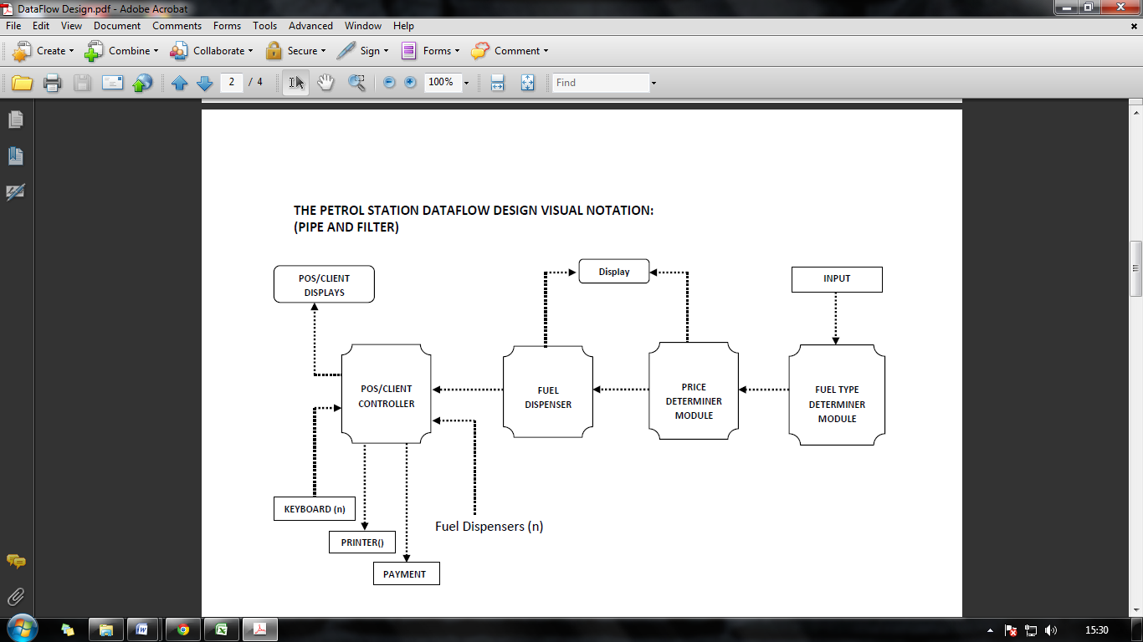

**DESIGN EVALUATION:**

|  |  |  |  |  |
| --- | --- | --- | --- | --- |
| Scenario | | | Change | |
| No. | Description | Type | Component | Change |
| 1 | User wants to add the facility to charge electric vehicles. | In-Direct | POS/Client Controller | It will need to show the amount or electricity used. |
| 2 | User wants to add a new pump from a different manufacturer. | Direct | - | - |
| 3 | User wants a new interface for the cashier with touch screen | In-Direct | POS/Client Display | This component would need to be modified as it is the interface for the cashier |
| Keyboard | This component will no longer be required. |
| 4 | User wants to accept payment via an NFC device | In-Direct | Payment | NFC technology would have to be implemented in order to allow the use of such devices. |
| 5 | User wants to add pay at pump facility | In-Direct | Fuel Dispenser | It will need modifying in order to enable it to process a transaction and add card-reading technology. |
| POS/Client Controller | This would have to handle transactions that are closed at the pump. |
| 6 | User wants to add an additional grade of fuel | In-Direct | Input | Extra Nozzle will have to be installed |
| Fuel Type Determiner | This will have to be modified in order to enable it to determine the new grade. |
| Price Type Determiner | Will have to be modified in order to enable it to determine the new price. |
| Fuel Dispenser | Will have to be modified in order to enable it to dispense the new grade. |
| 7 | User wants to add another pump | Direct | - | - |
|
|
|
| 8 | User want to add another cashier console | Direct | - | - |
|
|
|
| 9 | User want to add the ability to combine multiple pump usages into a single transaction | In-Direct | POS/Client Controller | They will be the need to modify the POS/Client Controller, to enable it to combine two or more transaction. |
|
|
|

